System Requirements Statement (SRS) –

OkStaff

**(Employee Attendance and Payroll Management** **System)**

Doc. Ref. : SRS_v0.4.doc

Version : 0.4

Status : Drafted

Created by :

Date : 01-Dec-2020

1. Introduction 3

2. Functional Requirements 4

2.1 Employee Module 5

2.2 Maneger Module 12

2.3 Admin Module 17

2.4 Use Case Diagram 19

THIS DOCUMENT CONTAINS 21 NUMBERED PAGES

# Introduction

This document explains the system requirements and scope for developing OkStaff System. OkStaff System could divide in three main parts, Employee part, Manager part, Admin part. This document describes the system requirement of the Account part.

# Functional Requirements

The Account part of OkStaff System has three modules which are divided in processes described as below.

|  |  |  |
| --- | --- | --- |
| **No** | **BRS requirement ID** | **Description** |
| **2.1** | **Employee Module** | |
| **2.1.1** | **F1** | **Account Creation Process** |
| **2.1.2** | **F2** | **Login Process** |
| **2.1.3** | **F3** | **Forgot Password Process** |
| **2.1.4** | **F4** | **Change Password Process** |
| **2.1.5** | **F5** | **Update Account Process** |
| **2.1.6** | **F6** | **Register Attendance** |
| **2.1.7** | **F7** | **Leave Application** |
| **2.2** | **Manager Module** | |
| **2.2.1** | **F9** | **Account Creation Process** |
| **2.2.2** | **F10** | **Login Process** |
| **2.2.3** | **F11** | **Forgot Password Process** |
| **2.2.4** | **F12** | **Change Password Process** |
| **2.2.5** | **F13** | **Update Account Process** |
| **2.2.6** | **F14** | **Register Attendance** |
| **2.2.7** | **F15** | **Search Employee** |
| **2.2.8** | **F16** | **Leave Request Response** |
| **2.3 Admin Module** | | |
| **2.3.1** | **F17** | **Login Process** |
| **2.3.2** | **F18** | **Search List of Present /Absent Employee** |
| **2.3.3** | **F19** | **Salary Calculation** |
| **2.3.4** | **F20** | **Payslip Report Generation** |
| **2.3.5** | **F21** | **Accounts Management** |

## 2.1 Employee Module

* Employee is the user of system who wants to register into the system and then he can mark his attendance and can apply for leaves.

### 2.1.1 Account Creation Process

* OkStaff application compels to create the account before using it. So, OkStaff application should provide the function which makes Employees creates new account.
* When Employee creates new account, the function demands information described as below.

1. Login information
2. Contact Details

* The Login information

The Login information consists of some items described as below.

1. EmployeeID
2. Password
3. First Name
4. Last Name
5. User Type
6. DepartmentID
   * All items are compulsory demanded.
   * EmployeeID

* The EmployeeID should be unique. If the EmployeeID correspond with not case-sensitive to other which is previously registered, the EmployeeID should not be registered as an account.
  + Password
* The Password has constrained which makes the Password consists of more than or equal 8 and less than or equal 16 characteristics including characters described as below.

1. Numeric figure (at least one)
2. Capital alphabet (A-Z) (at least one)
3. Small alphabet (a-z) (at least one)
4. Special character (#, $, %, &, etc.) (at least one)

* The Password is masked by dummy characters. The re-entering Password is demanded.
* The Password must be encrypted in OkStaff application.
  + User Type

The User Type falls into three categories described as below.

1. Employee
2. Manager
3. Admin

* The User Type defines also three types of user; "Employee", "Manager", and "Admin”.
* In an Account Creation Process, the user can select Employee.
* No one could select The Admin, because Admin is implemented to OkStaff application in advance.
* Contact Details
* The Contact Detail consists of some items described as below.

1. Permanent Address
2. Contact Phone No
3. Email Id
   * All items are compulsory demanded.
   * Permanent Address

* Permanent Address should be filled.
* But only the state should be selected from options.
* The Security Question information

The Security Question information is needed when Employee lost their Password. This information consists of two items described as below.

1. Selected Question
2. Answer
   * All items are compulsory demanded.
   * Some questions which are difficult to answer for anyone else are prepared in advance.

E.g. which color do you like most?

* + A question should be selected from options by the Employee, and the Answer is registered by the Employee.
* Login information should be entered on one screen, and then Employee information and Security Question information should be entered on another screen.

### 2.1.2 Login Process

* OkStaff application always compels user authentication before using itself except when a new account is successfully created.
* The user authentication demands EmployeeID and Password. The EmployeeID and the Password should be checked in three ways.
  + First, The EmployeeID and the Password should be existed and correct.
* If the EmployeeID and the Password are not equal to what the user has registered, the user authentication cannot be provided.
  + Second, the User Type linked to the Employed should be "Employee".
* When the User Type is "Employee", then user can be placed on “Employee Home”.
  + Finally, EmployeeID should be available.
* The Admin can decide whether the EmployeeID is available or suspended – Refer to the SRS of the Admin part.
* If Employee is rejected, user authentication is not provided for system user.
* The Employee account should alive for so long as the duration decided by Admin.
* Only when the three checks are successfully completed, Employee can be placed on respected page.
* The “Employee Home” provides some items described as below.

1. A trigger to logout
2. A trigger to Change Password
3. A trigger to Update Account
4. A trigger to Leave application

### Forgot Password Process

* When system user lost their Password, the recovery method should be provided by OkStaff application.

The recovery method is described as below.

* + First, system user enters their EmployeeID for OkStaff application.
  + Next, OkStaff application demands the Answer which has been registered since when the Account was created.
  + Only when the Answer is correct, Employee will get the new password by E-mail which also has been registered since when the Account was created.
  + The new password is automatically generated by OkStaff application.
* Of course, the new password should consist of more than or equal 8 and less than or equal 16 characteristics including at least a numeric figure, a capital alphabet, a small alphabet, and a special character.
* As a consequence, The Employee could get the Employee authentication using the new password.
  + Then, the Employee had better change the new password manually.
* If the Answer is not correct, otherwise, the correct Answer is demanded for user again.
  + In that case, Of course, Employee couldn’t get the new password.

### Change Password Process

* When Employee wants to change their Password, the measure should be provided by OkStaff application.
* Therefore, OkStaff application should provide the function which is available after getting the Employee authentication.
* The function demands the current password and the new password.
  + Of course, the new password should consist of more than or equal 8 and less than or equal 16 characteristics including at least a numeric figure, a capital alphabet, a small alphabet, and a special character.
  + The current password and the new password are masked by using dummy characters.
  + The new password is demanded to enter twice to avoid a typing error.
* Only when the current password is correct, Employee could change their Password.
* When the current password is changed into new password, OkStaff application compels user authentication again.

### Update Account Process

* OkStaff System should provide the function which makes the account updated for employee.
* The information employee could update is described below.

1. Login information
2. User information
3. Security Question Information

* The Login information

The updatable items as described below.

1. EmployeeID
   * All items are compulsory demanded, but updating is optional.

* The User information

The updatable items as described below.

1. Employee Name
2. Contact Number
3. E-mail address
4. Permanent address
5. User Type
   * All items are compulsory demanded, but updating is optional.

* The Security Question information

The updatable items as described below.

1. Selected Question
2. Answer
   * All items are compulsory demanded, but updating is optional.

### Register Attendance

* Employee can mark his attendance using In-time button present on the home page after Login.
* After marking the attendance, In-time will be automatically logged in Database.

### Leave application process

* After login to account, employee can apply for leave by selecting which type of leave.
* There are 3 types of leaves:

1. Leave without pay
2. Sick leave
3. Paid leave

#### Manager Module

### Account Creation Process

* OkStaff System compels to create the account before using it. So, OkStaff System should provide the function which makes manager creates new account.
* When manager creates new account, the function demands four information described as below.

1. Login information

2. Contact Details

3. Security Question Information

* The Login information

The Login information consists of some items described as below.

5. User ID

6. Password

7. First Name

8. Last Name

9. E-mail address

10. User Type

* + All items are compulsory demanded.
  + EmployeeID
* The EmployeeID should be unique. If the EmployeeID correspond with not case-sensitive to other which is previously registered, the EmployeeID should not be registered as an account.
  + Password
* The Password has constrains which makes the Password consists of more than or equal 8 and less than or equal 16 characteristics including characters described as below.

1. Numeric figure (at least one)

2. Capital alphabet (A-Z)(at least one)

3. Small alphabet (a-z)(at least one)

4. Special character (#, $, %, &, etc.) (at least one)

* The Password is masked by dummy characters. The re-entering Password is demanded.
* The Password must be encrypted in OkStaff System.
  + User Type

The User Type falls into three categories described as below.

1. Employee

2. Manager

3. Admin

* The User Type defines also three types of user; "Employee user", "Manager user", and "Admin user”.
* In an Account Creation Process, the user can select Manager.
* No one could select The Admin, because Admin is implemented to OkStaff System in advance.
* Contact Details
* The Contact Detail consists of some items described as below.

1. Permanent Address

2. Contact Phone No

* + All items are compulsory demanded.
  + Permanent Address
* Permanent Address should be filled.
* But only the state should be selected from options.
* The Security Question information

The Security Question information is needed when Manager lost their Password. This information consists of two items described as below.

1. Selected Question
2. Answer
   * All items are compulsory demanded.
   * Some questions which are difficult to answer for anyone else are prepared in advance.

E.g. which color do you like most?

* + A question should be selected from options by the Manager, and the Answer is registered by the Manager.
* Login information should be entered on one screen, and then Manager information and Security Question information should be entered on another screen.

### Login Process

* OkStaff System always compels Manager Authentication before using itself except when a new account is successfully created.
* The user authentication demands EmployeeID and Password. The EmployeeID and the Password should be checked in three ways.
  + First, The EmployeeID and the Password should be existed and correct.
* If The EmployeeID and the Password are not equal to what the user has registered, the user authentication cannot be provided.
  + Second, the User Type linked to the EmployeeID should be "user".
* When the User Type is "Manager ", user can be placed on “Manager Home”.
  + Finally, EmployeeID should be available.
* The Admin can decide whether the EmployeeID is available or suspended – Refer to the SRS of the Admin part.
* If user is rejected, user authentication is not provided for Manager.
* The Manager account should alive for so long as the duration decided by Admin.
* Only when the three checks are successfully completed, Manager can be placed on respected page.
* The “Manager Home” provides the some items described as below.

1. A trigger to logout
2. A trigger to update Account
3. A trigger to Change Password
4. A trigger to Search employee
5. A trigger to Leave Management
6. A trigger to schedule task

### Forgot Password Process

* When manager lost their Password, the recovery method should be provided by OkStaff system.

The recovery method is described as below.

* + First, manager enters their EmployeeID for OkStaff System.
  + Next, OkStaff System demands the Answer which has been registered since when the Account was created.
  + Only when the Answer is correct, Manager get the new password by E-mail which also has been registered since when the Account was created.
  + The new password is automatically generated by OkStaff System.
* Of course, the new password should consist of more than or equal 8 and less than or equal 16 characteristics including at least a numeric figure, a capital alphabet, a small alphabet, and a special character.
* As a consequence, The Manager could get the user authentication using the new password.
  + Then, the manager had better change the new password manually.
* If the Answer is not correct, otherwise, the correct Answer is demanded for manager again.
  + In that case, Of course, Manager couldn’t get the new password.

### Change Password Process

* When Manager wants to change their Password, the measure should be provided by OkStaff System.
* Therefore, OkStaff System should provide the function which is available after getting the Manager authentication.
* The function demands the current password and the new password.
  + Of course, the new password should consist of more than or equal 8 and less than or equal 16 characteristics including at least a numeric figure, a capital alphabet, a small alphabet, and a special character.
  + The current password and the new password are masked by using dummy characters.
  + The new password is demanded to enter twice to avoid a typing error.
* Only when the current password is correct, Manager could change their Password.
* When the current password is changed into new password, OkStaff System compels Manager authentication again.

### Update Account Process

* OkStaff System should provide the function which makes the account updated for Manager.
* The information Manager could update is described below.

1. Login information

1. User information
2. Security Question Information

* The Login information

The updatable items as described below.

1. First Name
2. Last Name
3. E-mail address
   * All items are compulsory demanded, but updating is optional.

* The User information

The updatable items as described below.

1. User Name
2. User Phone No
3. E-mail address
4. Permanent address
   * All items are compulsory demanded, but updating is optional.

* The Security Question information

The updatable items as described below.

1. Selected Question
2. Answer
   * All items are compulsory demanded, but updating is optional.

### Register Attendance

* Manager can mark his attendance using In-time button present on the home page after Login.
* After marking the attendance, In-time will be automatically logged in Database.

#### Search Employee

• Search conditions are described as below.

1. Employee Id
2. Department Id

* As the result of searching Requirements, Manager could see the list of employees which are available in organization.

1. Employee Id

2. Employee Name

3. Employee Email

4. Employees Department Name

5. Contact Number

6. Employee Salary

#### Leave Request Response

* Initially response will be considered as waiting for approval.
* Manager can approve request or reject on the basis of their requirement.
* Manager could see the information of present and absent employees.

### Schedule Employee’s task

* Employee can monitor the task appointed by his Manager

#### 2.3 Admin Module

* Adminshould be responsible for following activities**.**

### 2.3.1 Login Process

* OkStaff System always compels user authentication before using itself except when a new account is successfully created.
* The user authentication demands EmployeID and Password. The EmployeeID and the Password should be checked in three ways.
  + First, The EmployeeID and the Password should be existed and correct.
* If the EmployeeID and the Password are not equal to what the admin has registered, the Admin will be failed to login.
  + Second, the User Type linked to the EmployeeID should be "Admin".
* When the User Type is "Admin", user can be placed on “Admin Home”.
* Only when the three checks are successfully completed, Admin can be placed on respected page.
* The “Admin Home” provides the some items described as below.

1. A trigger to logout
2. A trigger to Update Account
3. A trigger to Change Password
4. A trigger to Remove Employee account.
5. A trigger to Search list of Employees.
6. A trigger to Calculate Salary of Employees.
7. A trigger to Generate Pay-Slip.

### 2.3.2 Search list of Present/Absent Employee

* Admin can view the list of all present and absent employees according the date.

### 2.3.3 Salary Calculation

* Admin is able to see Attendance sheet by searching Employee-id (working days, leaves taken, overtime) of all Employees.
* Salary is deducted if leave type is LWP.
* Extra Salary is added if Overtime or allowances is generated.
* Fixed Percentage of PF is deducted from total Salary calculated.
* Salary sheet is generated.

### 2.3.4 Pay Slip Record Generation

* Admin should able to see all the records of Employee.
* Daily report of enrolment to admin.
* Monthly Payslip is generated as per the Salary sheet.

### 2.3.5 Accounts Management

* Admin should able to manage all the Employee accounts with following activities.
* Remove Employee accounts
* Only Admin can delete account of Employee who has left organization.
* Update Employee accounts
* Only Admin can update salary and allowances to particular employee.

#### 2.4 Use Case Diagram

**Admin:**

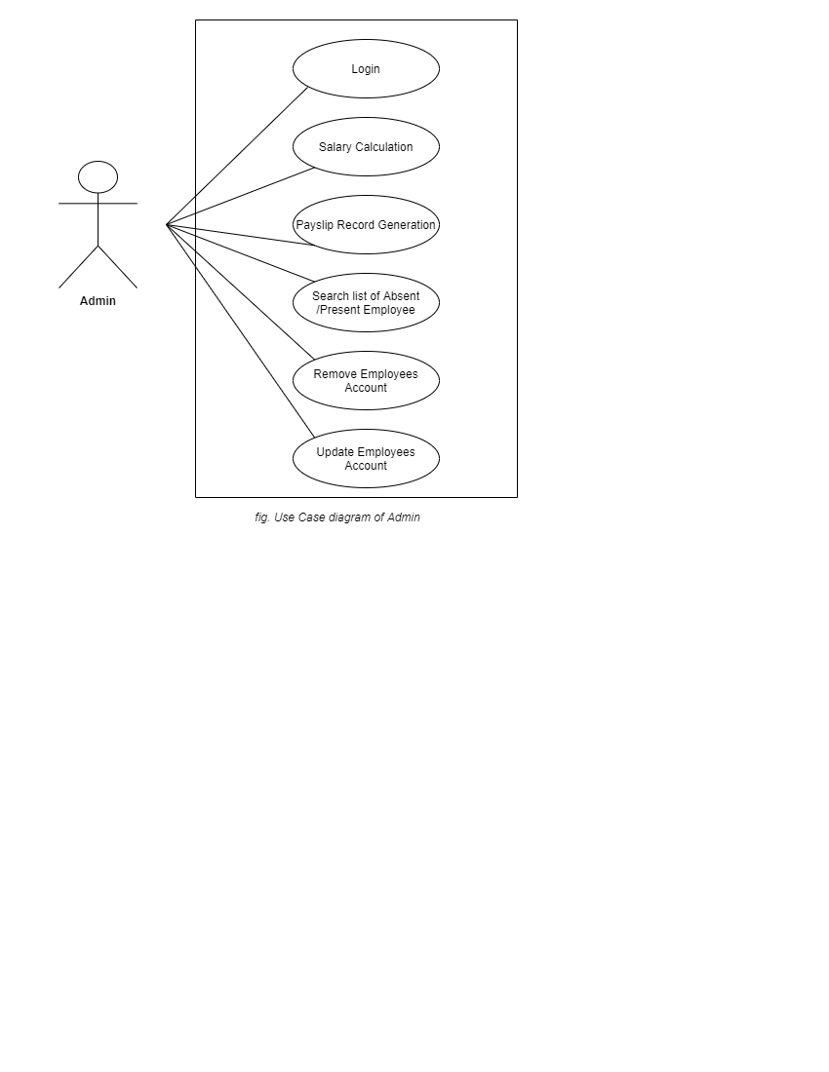

1. In Admin use case diagram Admin is the Actor.
2. Admin can handle following use case
3. Login
4. Salary Calculations
5. Pay Slip Generation
6. Search list of Present/ Absent Employees
7. Remove Employees Account
8. Update Employees Account

**Employee:**

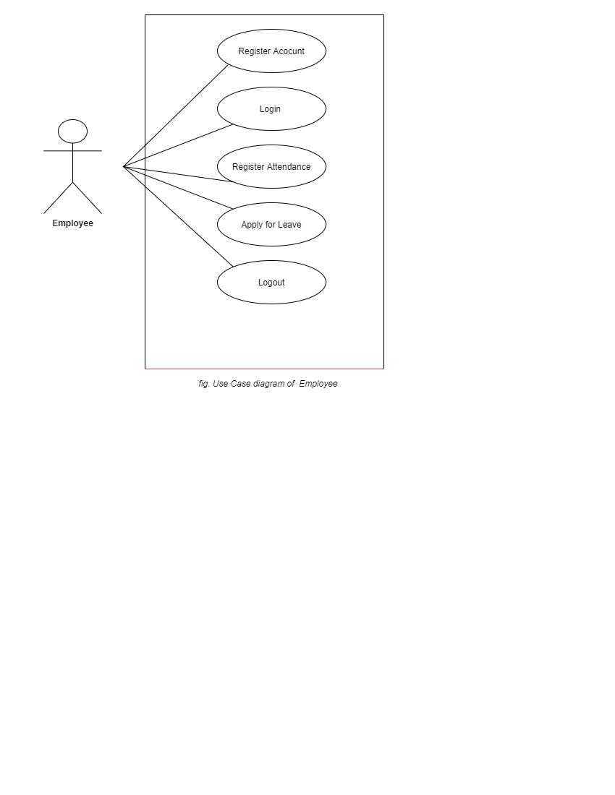

1. In Employee use case diagram Employee is the Actor.
2. Employee can handle following use cases:
3. Register
4. Login
5. Register Attendance
6. Apply for leave
7. Logout

**Manager**:

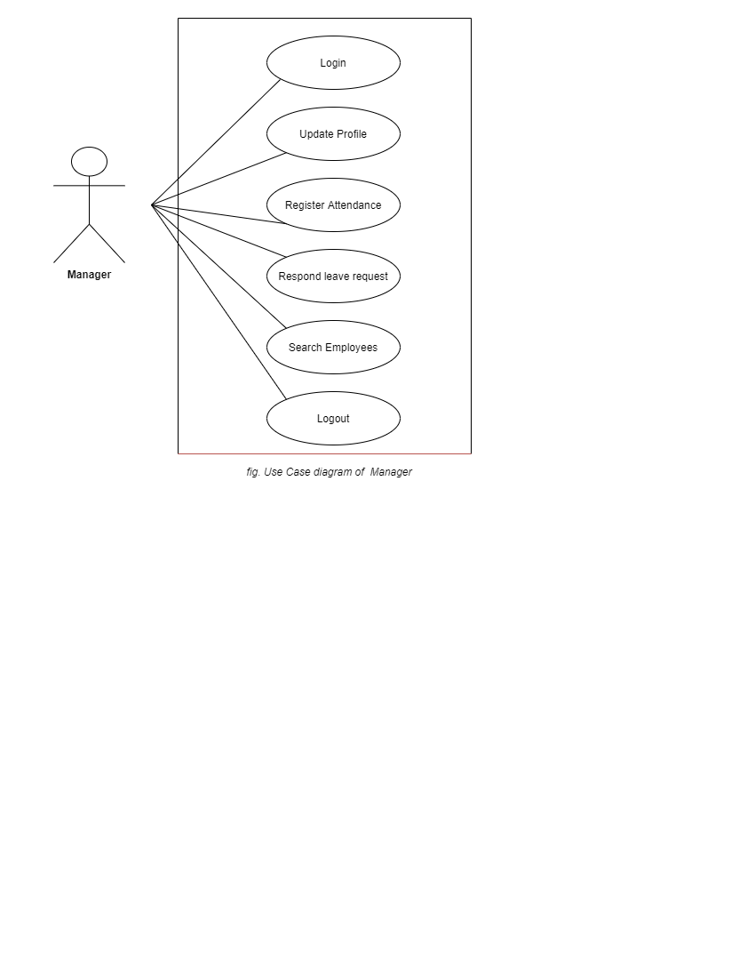

1. In Manager use case diagram Manager is the Actor.
2. Manager can handle following use cases:
3. Login
4. Update Profile
5. Register Attendance
6. Respond Leave request
7. Search Employee
8. Logout

s